MASSAGE

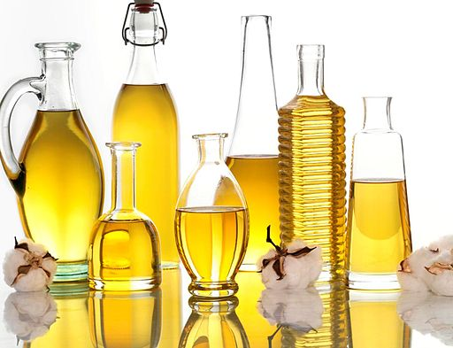
Physical effects of massage include muscle relaxation, blood pressure regulation, stimulation of the circulatory and digestive systems and detoxification. Emotional benefits are relaxation, stress relief and re- centering by allowing important "me" time. In addition, massage has been shown to be effective in relieving pain, as touch impulses travel to the brain faster than pain stimuli and the therapeutic touch sensation is translated in the brain into the release of endorphins, the so-called "feel-good" hormones. These reduce pain perception and increase relaxation through curbing the release of stress hormones.
Image attributed to http://www.flickr.com/photos/cottonseedoiltour/5052424228/

Through these mechanisms regular, appropriate massage therapy promotes optimal functioning of natural physiology. In pregnancy and childbirth, this can be very beneficial, for example to:

- Promote uncomplicated pregnancy and birth physiology

- Mitigate the effects of internal and external stressors

- Relief minor aches and pains in pregnancy

- Avoid or reduce water retention/oedema

- Prepare emotionally for labour and parenthood

- Pain relief in labour and after birth

We offer treatments with safe intuitive massage techniques for pregnancy, birth and the puerperium, combining, where appropriate and desired by you, with aromatherapy and/or gentle acupressure. We can also teach you some self- and partner massage techniques, pointing out specific adjustments in posture and technique for safe, effective massage in pregnancy, during and after birth.

We can also teach techniques for perineal massage, which is recommended for 1st time mothers from 36 weeks gestation to reduce the risk of perineal trauma (tears) during vaginal birth.

