AROMATHERAPY

Aromatherapy oils work in two distinct but complementary ways:
A. Absorbed into the bloodstream, either through the skin or the airways, their various, complex biochemical components have pharmaceutical effects on the body.

B. In addition, through the sense of smell the aromas also directly affect the emotional centre of the brain (amygdala), eliciting positive emotional responses such as relaxation, mental focus, invigoration etc., which corroborate and maximise the pharmaceutical therapeutic benefits.

As essential oils typically consist of a multitude of complex chemical constituents, their individual doses remain low, making them generally very safe to use. However, since they absorbed into the bloodstream and metabolised like pharmacological drugs they can also cross the placenta to your baby. So in pregnancy they should always only be used under the supervision of an expert practitioner, who will ensure the oils used have an excellent safety profile for pregnancy, are of the highest quality and are administered at the right time, for the right purpose, in the right dose.
Image attributed as own work to Florame, France.

We offer maternity aromatherapy particularly for the following indications:

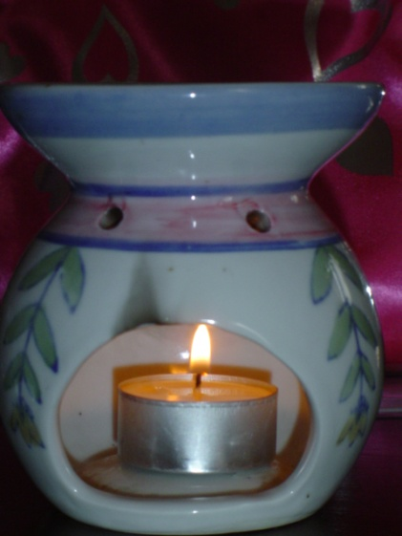
- Nausea and vomiting in pregnancy
- Other digestive symptoms such as constipation, wind, gastric reflux (indigestion)
- Anxiety and stress
- Insomnia
- Nasal congestion, minor coughs and colds
- Minor aches and pains
- Carpal tunnel syndrome
- Promotion of onset of natural labour at term
- Pain relief in labour
- Stimulation of effective labour contractions
- Natural delivery of the placenta (afterbirth)
- Afterpains and natural involution of the uterus (womb ) after birth
- Breast care during breast feeding
Image attributed to Eggybird at http://flickr.com/photo_zoom.gne?id=38930060&size=m

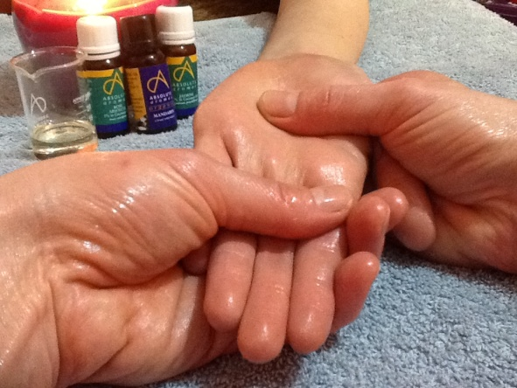
At our aromatherapy sessions we select and blend appropriate essential oil combinations specifically for your case presentation and aroma preferences. Your aromatherapy can then be administered to you in various forms:

- Massage- hands, feet, full body

- Bath/shower additives

- Inhalation

- Compresses

- Creams

